**Department of Electrical Engineering**

|  |  |
| --- | --- |
| **Faculty Member:____________________** | **Dated: ____________________** |
|  |  |
| **Course/Section:____________________** | **Semester: __________________** |
|  |  |

**EE-232 Signals and Systems**

**Lab #8 Fourier Series**

|  |  |  |  |  |
| --- | --- | --- | --- | --- |
| **Name** | **Reg. no.** | **Report Marks / 10** | **Viva Marks / 5** | **Total/15** |
|  |  |  |  |  |
|  |  |  |  |  |
|  |  |  |  |  |
|  |  |  |  |  |

**Lab8: Fourier Series**

**Objectives**

The goal of this laboratory is to be able to calculate the fourier series of approximately continuous time and discrete time signals and plot the real part of the spectrum / Fourier series coefficients.

* MATLAB Demos on Fourier series
* Fourier Series Calculation of Discrete Time Signals
* Inverse Fourier Series Calculation given Fourier Series Coefficients
* Determine Frequency Response of an LTI Causal System

**Lab Instructions**

* This lab activity comprises of three parts: Pre-lab, Lab Exercises, and Post-Lab Viva session.
* The Pre-lab tasks should be completed before coming to the lab. The reports are to be submitted on LMS.
* The students should perform and demonstrate each lab task separately for step-wise evaluation
* Only those tasks that completed during the allocated lab time will be credited to the students. Students are however encouraged to practice on their own in spare time for enhancing their skills.

**Lab Report Instructions**

All questions should be answered precisely to get maximum credit. Lab report must ensure following items:

* Lab objectives
* MATLAB codes
* Results (graphs/tables) duly commented and discussed
* Conclusion

# Fourier Series of Discrete Time Signals

## Pre-Lab

### Introduction

For a signal ***x[n]***with fundamental period N, the DTFS synthesis and analysis equations are given by (1) and (2), respectively.

$x\left[n\right]= \sum_{k=0}^{N-1}{a_{k}e^{jk(\frac{2π}{N})n}}$ (1)

$a_{k}= 1/N\sum_{n=0}^{N-1}{{x[n]}_{*}e^{-jk(\frac{2π}{N})n}}$ (2)

Remember that *x[n]* has period *N ,* so that the summation in **(2)** can be replaced with a sum over any N consecutive values of *n.* Similarly, ***ak*** is periodic in ***k*** with period **N** so that the summation in **(1)** can be replaced with a sum over any **N** consecutive values of **k**.

MATLAB contains efficient routines for computing **(1)** and **(2).** If x is an N-point vector for the period 0 ≤ *n* ≤N - **1,** then the **DTFS** of *x[n]*can be computed by **ak=(l/N)*fft(x)**, where the N-point vector a contains ***ak*** for 0 ≤k ≤N - 1. **The function fft is simply an efficient implementation of (2) scaled by N**. **Thus, DTFS can by computed by typing ak=(l/N)*fft(x).** The function will return both real and imaginary parts of the DTFS coefficients.

Given a vector containing the DTFS coefficients ***ak*** for 0 ≤k ≤N - 1, the function **ifft** can be used to construct a vector x containing *x[n]* for 0 ≤ *n* ≤N – 1 as x=N*ifft (a). The function **ifft** is an efficient realization of the DTFS synthesis equation, scaled by 1/N.

### Computing Frequency Response of Causal LTI System in MATLAB

The signals **ejwn** are eigenfunctions of LTI systems. This means that if a complex exponential is input to a causal LTI system the output will be a scaled version of the same complex exponential. Thus, indicating that an LTI system cannot generate new frequencies. For each value of **ω** the frequency response **H(ejω)** is the eigenvalue of the LTI system for the eigenfunction **ejωn**; when the input sequence is x[n] = $e^{jω_{0}n}$, the output sequence is y[n] = $H(e^{jω})e^{jω_{0}n}$. For a causal LTI system described by a difference equation, the command [H,omega] =freqz (b ,a ,**N)** computes the frequency response H(ej**ω**)at N evenly spaced frequencies between 0 and $π$.

### Fseriesdemo and sinesum2 demo:

These demos concentrate on the use of MATLAB GUI for Fourier series.

* **fseriesdemo:** FourierSeriesDemo is a GUI that shows Fourier Series synthesis for different number of Fourier coefficients. Different signals can be selected: square wave, sawtooth, triangle and rectified sinusoids.
* **sinesum demo:** sinesum demo helps us to take the sum of sinusoids to create more complex signals.

You have been provided the zip files for both. Extract them to the MATLAB working directory or extract them to any directory of choice and include the path in MATLAB. We can run the demos by writing the following commands on the **Command Window.**

**>> fseriesdemo**

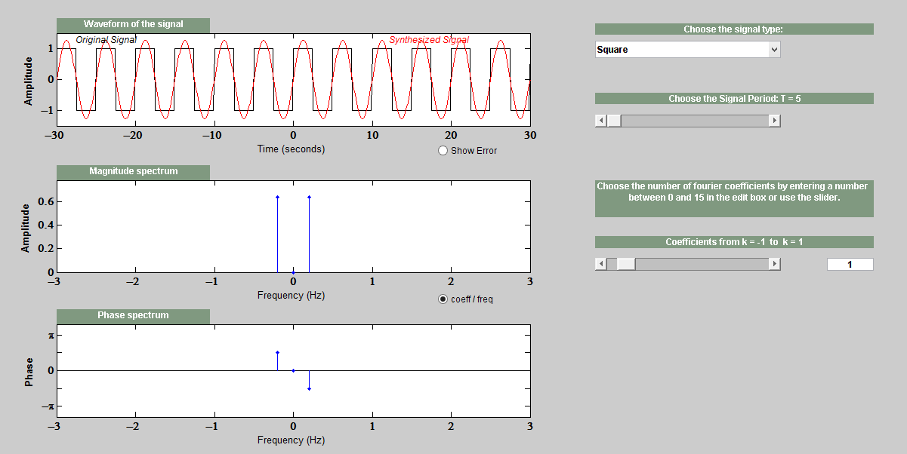

**Pre Lab Task 1**

Your task is to create a sawtooth waveform with T=10sec and increase the number of Fourier coefficients. Observe and state the significance of increasing number of coefficients. Also provide the screenshot.

**>> sinesum2**

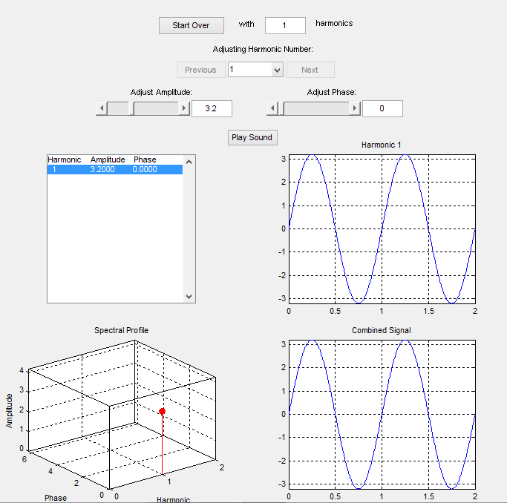

**Pre Lab Task 2**

Your task is to increase the number of harmonics to 5. Change the amplitude of these harmonics. Explain the effect of changing the number of harmonics in the sinesum demo. Also provide the screenshot.

## Lab Tasks

### Lab Task 1:

#### Fourier series of a Cosine wave

Write a function that will generate a single sinusoid, x[n] = A cos (kω). Determine the fourier series coefficients and plot only the real part of fourier series coefficients when A=1 and **kω** = 2*pi*k/T and k=10 and T =10.

NOTE:

* For calculating the fourier series coefficients use the matlab function ‘fft’.
* Add the figures of both the time domain and frequency domain representation of the singals with appropriate labels and titles.
* Choose an appropriate value of ‘time_increment’ during the generation of cosine function.

**for t=0:time_increment:T**

**%Generate Cosine Wave**

* % Hint for calculating the fourier series and displaying its real part

**L=length(signal);**

**y=real(fft(signal,L))/L;**

**stem(y);**

In case of the given signal t and T are being used in place of n and N because the increment between 0 and T will have small increments than 1.

#### Fourier Series of a Continuous Time Rectangular wave

Assume a rectangular wave as shown below. Assume that there are a finite number of values between 0 and 1 and when seen from a distance the function appears to be continuous (We know that this is not, specially for discrete systems such as computers). Using the fft function determine the fourier series of the rectangular waveform. Plot the fourier series coefficients.

1

…………….

……………………….

0 1 2 3 4 5

t

### Lab task 2:

#### Inverse Fourier Series Calculation

Using the function ‘ifft’ and knowledge of FS coefficents of a Cosine waveform determine the signal x[n]. For the lab report plot both the fourier coefficients and time domain signal.

**Now assuming that the DTFT was N Point DTFT or FFT. Then the fourier Series Coefficients of x[n] = cos (pi/4) n will have impulses at locations k and N-k.**

**ωk = 2 pi k /N If ωk = pi/4 Then k = N/8 Where N is the N point DTFT or FFT. Assuming that N =1024 locations k and N-k can be calculated. So the coeff_array will be an array of size N with fourier series coefficients of a cosine waveform at locations k and N-k.**

**%HINT**

**y=ifft(coeff_array,N); %N is number of points in the Inverse FFT**

**stem(real(N*y));**

### Lab Task 3:

#### Frequency Response of an LTI System

(a) Assume a causal system h[n] =[1 1]. Such a system can be written in terms of a difference equation relating input x[n] to ouput y[n]. Write the system in terms of x[n] and y[n] and then using the matrix notation shown below determine the frequency response of the causal LTI system.

%HINT : Assume that the difference equation is y[n-1]-2y[n]=5x[n-1]+x[n]

b=[5 1];

a=[1 -2];

[Magnitude_ans,Phase_ans]=freqz(b,a,1024);

(b) Repeat the procedure for the system h[n] = [-1 1]